**Task 14 / Project Report**

**Computer Networks (Lab)**



**Submitted to Mr. Rasikh Ali  
Submitted by Addan Abdullah**

**Roll #: SU92-BSSEM-F22-059  
Section: SE-5B**

**Submitted on Dec 9th, 2024**

**DEPARTMENT OF SOFTWARE ENGINEERING  
SUPERIOR UNIVERSITY, LAHORE**

Contents

**No table of contents entries found.**

**No table of figures entries found.**

Project Report

# Overview

The project is a network model for a generic medium sized organization. The organization is based in a building with three floors. Each floor has some departments. Following is list of departments in each floor:

* Ground Floor
  + Customer Relations Department
  + Guest Room
* First Floor
  + Finance And Accounts Department
  + Marketing Department
  + IT Department
* Second Floor
  + HR Department
  + Admin Department

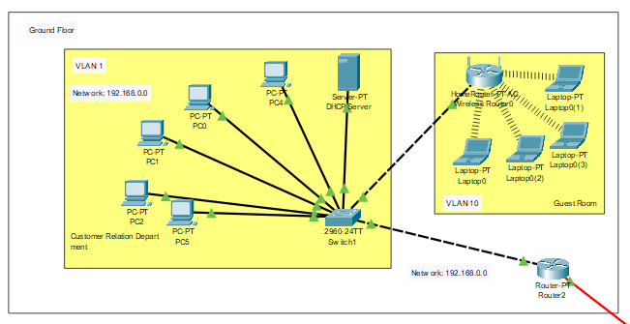

Figure 1: Ground Floor Schematic

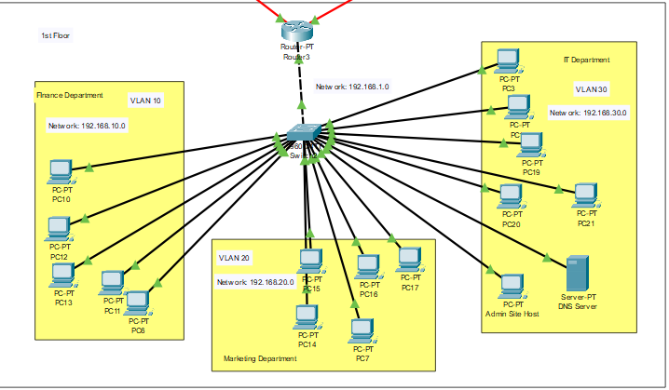

Figure 2: First Floor Schematic

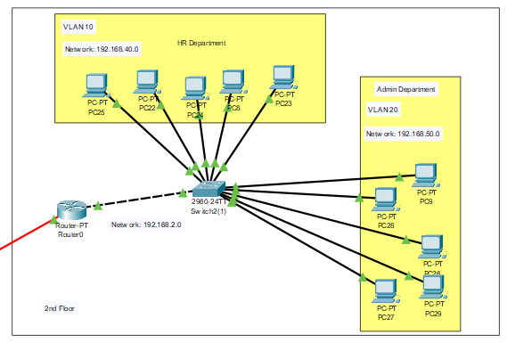

Figure 3: Second Floor Schematic

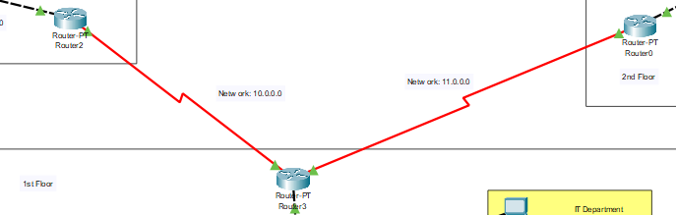

Figure 4: Interconnection between routers

# Commands

To configure various devices with DHCP, routing, VLAN and inter-VLAN, we need to use commands. Following are the commands used at different devices to configure them.

## VLAN (at Switches)

enable

config terminal

#make the VLANs first

vlan 10                   #give vlan a number

name HR                   #name the vlan

#assign the vlans now to pc

int range fa0/1 - 10      #this should be replaced with range of ports that you want to assign VLANs to.

switchport mode access

switchport access vlan 10 #change the 10 with the vlan you want to assign to these ports

#repeat the above for all vlans

#configure router port

int gig0/1                #select routers port on switch

switchport mode trunk

## Inter-VLAN (at Routers)

enable

config terminal

int fa0/1

no shutdown

#select interface with port.vlan

int fa0/1.10

encapsulation dot1q 10

ip add 192.168.10.1 255.255.255.0

int fa0/1.20

encapsulation dot1q 20

ip add 192.168.20.1 255.255.255.0

#repeat for all vlans

## DHCP (at Routers)

#select interface with port.vlan

int fa0/1.10

ip dhcp pool pool1                  #use your choice of name instead of pool1

network 192.168.10.0 255.255.255.0  #use the ip and subnet mask of choice

default-router 192.168.10.1  
dns-server 192.168.10.1 #use the ip address of dns server

## Routing (at Routers)

router rip

network 192.168.0.0 255.255.255.0

network 10.0.0.0 255.0.0.0

#repeat for all routers with all networks of their ports

## DNS (at Routers)

enable

config terminal

ip name-server 192.168.30.100 #replace with the ip address of dns server

# IP Plan

|  |  |  |  |  |  |  |
| --- | --- | --- | --- | --- | --- | --- |
| **Floor** | **Department** | **Device** | **Port** | **Destination** | **VLAN** | **IP** |
| **Ground Floor** | *N/A* | Router2 | Fa0/0 | Switch1 | *N/A* | 192.168.0.0 |
| Se2/0 | Router3 | *N/A* | 10.0.0.0 |
| Customer Relation | Switch1 | Fa0/10 | Wireless Router0 | 10 | 192.168.10.0 |
| Gig0/2 | DHCP Server | 1 | 192.168.0.2 |
| Fa0/1 | PC | 1 | DHCP |
| Fa0/2 | PC | 1 |
| Fa0/3 | PC | 1 |
| Fa0/4 | PC | 1 |
| Fa0/5 | PC | 1 |
| Guest Room | Wireless Router0 | *N/A* | Laptop | *N/A* | DHCP |
| *N/A* | Laptop | *N/A* |
| *N/A* | Laptop | *N/A* |
| *N/A* | Laptop | *N/A* |
| *N/A* | Laptop | *N/A* |
| **First Floor** | *N/A* | Router3 | Se2/0 | Router2 | *N/A* | 10.0.0.0 |
| Se3/0 | Router0 | *N/A* | 11.0.0.0 |
| Fa0/0 | Switch2 | *N/A* | 192.168.1.0 |
| Finance | Switch2 | Fa0/1 | PC | 10 | DHCP |
| Fa0/2 | PC | 10 |
| Fa0/3 | PC | 10 |
| Fa0/4 | PC | 10 |
| Fa0/5 | PC | 10 |
| Marketing | Fa0/8 | PC | 20 | DHCP |
| Fa0/9 | PC | 20 |
| Fa0/10 | PC | 20 |
| Fa0/11 | PC | 20 |
| Fa0/12 | PC | 20 |
| IT | Fa0/15 | PC | 30 | DHCP |
| Fa0/16 | PC | 30 |
| Fa0/17 | PC | 30 |
| Fa0/18 | PC | 30 |
| Fa0/19 | PC | 30 |
| Fa0/20 | Admin Site Host | 30 | 192.168.50.101 |
| Fa0/21 | DNS Server | 30 | 192.168.50.100 |
| **Second Floor** | *N/A* | Router0 | Se3/0 | Router3 | *N/A* | 11.0.0.0 |
| Fa0/0 | Switch2(1) | *N/A* | 192.168.2.0 |
| HR | Switch2(1) | Fa0/1 | PC | 10 | DHCP |
| Fa0/2 | PC | 10 |
| Fa0/3 | PC | 10 |
| Fa0/4 | PC | 10 |
| Fa0/5 | PC | 10 |
| Admin | Fa0/13 | PC | 20 | DHCP |
| Fa0/14 | PC | 20 |
| Fa0/15 | PC | 20 |
| Fa0/16 | PC | 20 |
| Fa0/17 | PC | 20 |

# Tests

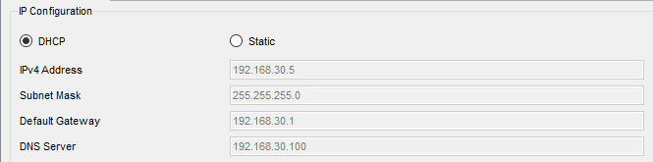

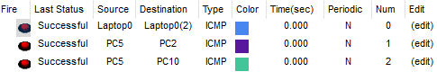



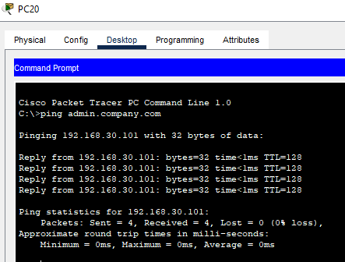

So, we can see that routing, inter-VLAN routing, DHCP and DNS are all working as intended.